Specification
Version: | 0.1
Author(s): | DH
Created: | 12/17/2008
Last modification: | 1/14/2009

Version | Date | Author(s) | Changes
0.1 | 12/17/2008 | DH | Initial version.
0.2 | 1/14/2009 | DH | Finished section 2.1 and 2.2

Overall Description

Product Perspective
DecidR is being developed within a collegiate software project (“StuPro A”) for the Institute of Architecture of Application System (IAAS) at the University of Stuttgart, Germany. The DecidR application is a completely new, self-contained product.

Product Functions
Since DecidR is a web application, users do not need a special client besides an up-to-date web browser to access its features. They must, however, register themselves on the DecidR web site in order to gain the full functionality. The following section summarizes the major functions that DecidR must let the user perform. Details are provided in section <insert reference here>.
- System management
  - Approve or decline new tenants.
  - Delete existing tenants.
  - Edit user profiles & master data.
- Tenant administration
  - Create, modify and delete workflow models.
  - Start workflow instances of the created models.
  - Share workflow models with other tenants by making them public.
  - Modify the tenant web page style such as a custom tenant logo.
  - Browse and manage a list of tenant members.
- Workflow administration
  - Send participation invitations to registered and unregistered users.
  - Monitor the status of running workflow instances.
  - Modify the data hold by running workflow instances.
  - Terminate running workflow instances.
- Workflow participation
  - Receive invitations and join existing tenants.
  - View your personal work list.
  - Complete or refuse tasks on your work list such as filling out a web form, uploading files, etc.
- Public start page
  - Log in with an existing user account.
  - Create a new user account with or without an invitation. Optionally create a new tenant or join an existing one when creating a new account.
  - Reset your password.
- Personal start page
  - Edit your personal profile including address data, password, membership status etc.
  - Join an existing tenant or become administrator of a new one.

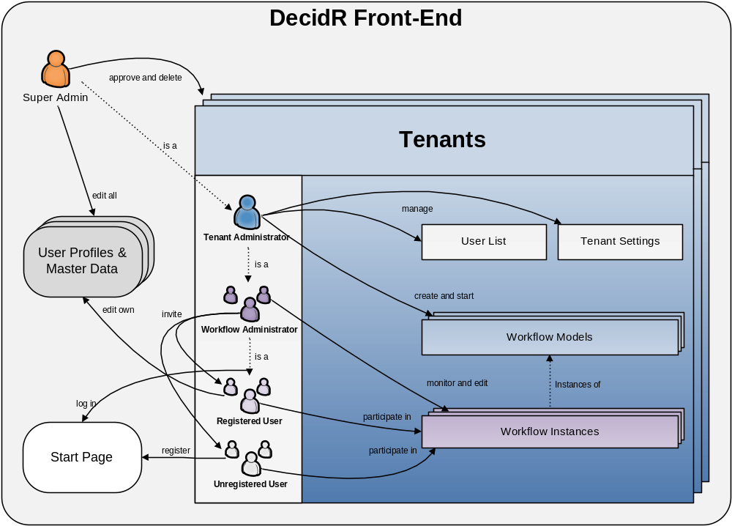
Figure 1: simplified conceptual view of the DecidR front-end

User Classes and Characteristics
<Identify the various user classes that you anticipate will use this product. User classes may be differentiated based on frequency of use, subset of product functions used, technical expertise, security or privilege levels, educational level, or experience. Describe the pertinent characteristics of each user class. Certain requirements may pertain only to certain user classes. Distinguish the most important user classes for this product from those who are less important to satisfy.>

Operating Environment
<DONE BY MF>

Design and Implementation Constraints
<Describe any items or issues that will limit the options available to the developers. These might include: corporate or regulatory policies; hardware limitations (timing requirements, memory requirements); interfaces to other applications; specific technologies, tools, and databases to be used; parallel operations; language requirements; communications protocols; security considerations; design conventions or programming standards (for example, if the customer’s organization will be responsible for maintaining the delivered software).>

User Documentation
<List the user documentation components (such as user manuals, on-line help, and tutorials) that will be delivered along with the software. Identify any known user documentation delivery formats or standards.>

Assumptions and Dependencies
<List any assumed factors (as opposed to known facts) that could affect the requirements stated in the SRS. These could include third-party or commercial components that you plan to use, issues around the development or operating environment, or constraints. The project could be affected if these assumptions are incorrect, are not shared, or change. Also identify any dependencies the project has on external factors, such as software components that you intend to reuse from another project, unless they are already documented elsewhere (for example, in the vision and scope document or the project plan).>

